Figs for modification/ editing

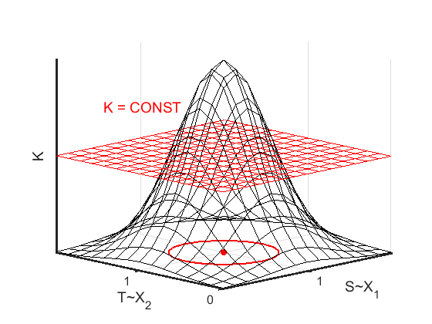



**Fig. 1**. Concave utility function *K*(S,T) and its indifference curve (in red) corresponding to points (S,T) where this function has constant value.



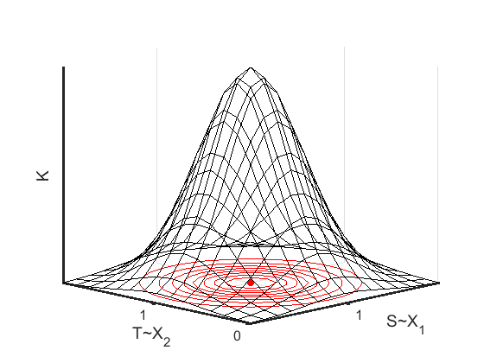

**Fig. 2** Several indifference curves for utility function *K*(S,T).

1. Indifference curves for participant A, where the maximum utility function UAmax is at the point (C1, C2). Utility function UA has smaller values for curves further away from this point.

1. Indifference curves for participant B, where the maximum utility function UBmax is at the point (C1, C2). Utility function UB has smaller values for curves further away from this point.

**Fig. 3**. Indifference curves for participants A and B.

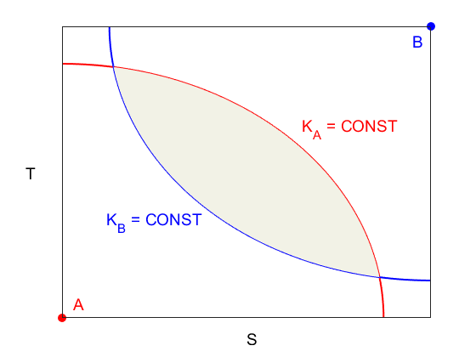

(a)



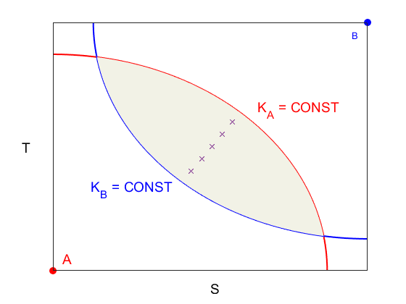

(b)

**Fig. 4**. The Edgeworth box diagram showing:

1. The shaded region where utility functions for both participants are larger than some constant value.
2. The *contract curve* line representing solution points optimal for *both* participants (shown by crosses).

1. Utility functions for Participants A and B have the same parameterization (~ bivariate Gaussian with the same width).

(b) Utility functions for Participants A and B have the same parameterization (~ bivariate Gaussian with different widths).

(c) Utility functions for Participants A and B have different parameterization (with the same relative weight 0.5)

(d) Utility functions for Participants A and B have the same parameterization (but different weights, 0.3 for A & 0.7 for B)

**Fig. 5**. Several examples of Edgeworth Box model presented in Kanridge-like form. Each figure shows 3D plots of the total utility function K(S,T), its ST- field in a shaded area, and optimal point (Sopt,Topt) shown in green.